Have You Ever Been In Love Celine Deon  Because You Love Me Jo Dee Messina  Breathe Faith Hill  Brown Eyed Girl Van Morrison  Bubbly Colbie Caillat  Faithfully Journey  From This Moment On Shania Twain  Good Morning Beautiful Steve Holy  How Do I Live LeAnn Rimes  I Could Not Ask For More Sara Evans  It's Your Love Tim McGraw  Keeper Of The Stars Tracy Byrd  No One Alicia Keys  Not On Your Love Jeff Carson  Only Love Wynonna Judd  Unchained Melody The Righteous Brothers  Something That We Do Clint Black  Wonderful Tonight Eric Clapton  You Raise Me Up Josh Groban  and Many more.... | 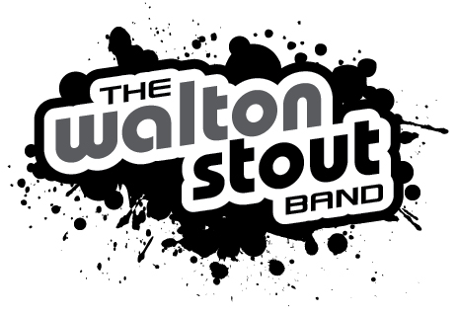  Soft Pop and Standards  Europa Gato Barbieri  Bubbly Colbe Caillet  What You Won't Do For Love Bobby Caldwell  What a wonderful World Loui Armstrong  Brown Eyed Girl Van Morrison  Fly Me To The Moon Frank Sinatra  At Last Etta James  Stand By Me Ben E King  Don't Know Why Nora Jones  Just The Two Of Us Grover Washington  Big Girls Don't Cry Fergie  You Send Me Sam Cook  Unchained Melody Righteous Brothers  Magic Colbie Caillet  Pocket Full of Sunshine Natasha Bedingfield  It Had To Be you Ray Charles | Party Songs!  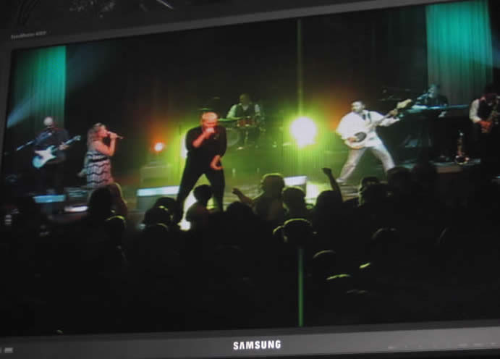  Super Freak Rick James  Give It To Me Baby Rick James  Let It Rock Kevin Rudolf  Cupid Shuffle Cupid  Mony Mony Billy Idol  Love Shack The B-52's  Sweet Home Alabama Lynyrd Skynyrd  I Love Rock and Roll Joan Jet  Centerfold J. Geils Band  Blister In The Sun Violent Femmes  Play That Funky Music Wild Cherry  Good Times The Hit Crew  Let's Groove Tonight Unspecified  Shake Your Groove Thing Peaches & Herb  Boogie Oogie Oogie A Taste of Honey  I Will Survive Gloria Gaynor  Ladies Night The Hit Crew  Working For The Weekend Loverboy  Harder To Breathe Maroon 5  867-5309/Jenny Tommy Tutone  Brick House The Commodores  My Life Would Suck Without You Kelly Clarkson  No One Alicia Keys  Big Girls Don't Cry Fergie  So What Pink  Who Knew (Main Version) Pink  Hard To Handle The Black Crowes  You Dropped A Bomb On Me The Gap Band  Shut Up and Drive Rihanna  Just A Girl Gwen Stefani  This Love Maroon 5  The House Is Rockin' Stevie Ray Vaughan  I Hate Myself For Loving You Joan Jett  What I Like About You The Romantics  Walk Away Kelly Clarkson  1999 Prince  Superstition Stevie Wonder  Hella Good No Doubt  4 Minutes Madonna  Kryptonite 3 Doors Down  Here For The Party Gretchen Wilson  I Want You To Want Me Cheap Trick  Hit Me With Your Best Shot Pat Benatar  Walk This Way Aerosmith  Get The Party Started Pink  Don't Stop The Music Rihanna  Give Me One Reason Tracy Chapman  Since U Been Gone Kelly Clarkson  Get Down Tonight KC & the Sunshine Band  Bad Girls Donna Summer  Le Freak Chic  Word Up Cameo  Say It Right Nelly Furtado  Lady Marmalade Labelle  Hot Stuff Donna Summer  Hot N Cold Katy Perry  Dani California Red Hot Chili Peppers  and Many more....

